EXPERIMENT-15
15. A genealogy application determines relationships among family members. Implement Family Knowledge Representation. Infer family relationships using logical rules.

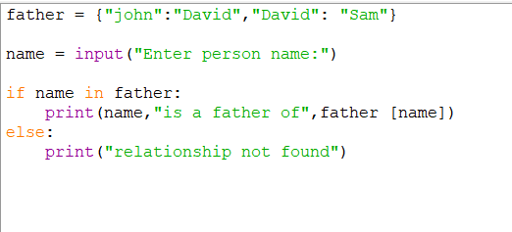
PROGRAM:

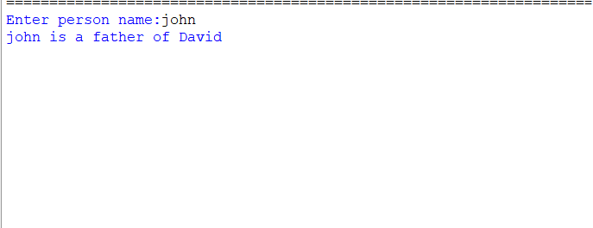
OUTPUT:

